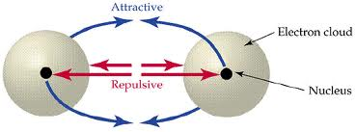
I.) Chemical Bond- A mutual attraction between the nuclei and valance electrons of different atoms that bond the atoms together.

A. Ionic Bond- a bond that results from the electrostatic attraction between positive and negative ions.
i. cation- an ion with a positive charge
1.) metals make these when they lose electrons in a chemical bond
2.) the number of electrons lost = the number of valance electrons
Ex: Calcium has 2 valence electrons … Calcium loses 2 electrons in a bond
Remember … you can find the number of valance electrons from the group number (1A- 8A)
3.) the charge on the ion = the number of electrons lost
Ex: Calcium lost 2 valance electrons = +2 ion
ii. anion- an ion with a negative charge
1.) non-metals make these when they gain electrons in a chemical bond
2.) the number of electrons gained = the number of valance electrons needed to
get to 8
Ex: Nitrogen has 5 valance electrons … Nitrogen will gain 3 electrons in a bond
3.) the charge on the ion = the number of electrons gained
Ex: Nitrogen gains 3 electrons in a bond = -3 ion
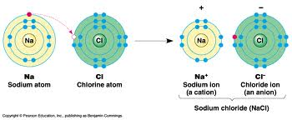

iii. crystal lattice- the arrangement of ions in an ionic compound in which the cations are surrounded by anions and the anions are surrounded by cations thus minimizing the repulsive forces and maximizing the attractive forces.
iv. lattice energy- the energy required to break apart one mole of an ionic compound into its gaseous state.
v. properties of ionic compounds: hard, brittle, rigid, solids at room temp, high melting points, high boiling points, electrolytes (solutions which conduct electricity)
B. Covalent Bond- a bond that results when two atoms share electrons. As the distance between the atoms decreases, the potential energy decreases … they become more stable.
i. polar covalent bond- when electrons are unequally shared
1.) the difference in electronegativity values give a range of 1.6- 0.3
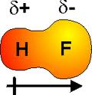
2.) Example:

ii. non-polar covalent bond- when electrons are equally shared
1.) the difference in electronegativity values give a range of 0.2- 0
2.) Example:
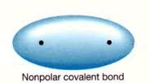
Cl
Cl

iii. properties of covalent compounds: low melting points, low boiling points, soft solids, mostly liquids and gases at room temp, volitle
C. Molecule- a neutral group of atoms held together by a covalent bond.
These two factors affect the strength of a chemical bond … the shorter the bond length- the higher the bond energy!
D. Bond Length- is one-half the diameter of the electron cloud.
E. Bond Energy- is the energy required to break a chemical bond.

II.) Valance Electrons are the ONLY electrons involved in a chemical bond; to determine, find the group number as it will tell you how many valance electrons the atoms have.

III.) Alone, atoms have a high potential energy … that is to say, they are unstable- chemical bonding provides stability for atoms.
A. Octet Rule- atoms would like to have 8 valance electrons in its outer shell to be stable.
B. Atoms will gain, lose, or share electrons to have a full valance shell.
IV.) Electronegativity- when atoms share electrons, the electrostatic attraction for the electrons in the bond is called electronegativity.
A. Metals
i. on the left of the “stair step”
ii. have low electronegativity values and therefore lose electrons in chemical bonds

B. Non- Metals
i. on the right of the “stair step”
ii. have high electronegativity values and therefore gain electrons in chemical bonds

C. The greater the difference in electronegativity values, the more ionic in character
D. No bond is purely ionic or purely covalent- the truth is somewhere in between.

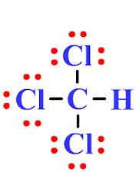
V.) Lewis Structures- show the types and numbers of atoms joined in a single molecule of a molecular compound; used to show how atoms share electrons in a bond.
A. Rules to be followed … you need to know these!
** Don’t forget exceptions to the octet rule: H needs 2e⁻, Be needs 4e⁻, B needs 6e⁻, and atoms beyond period 2 can accommodate an expanded octet of 10 to 12 e⁻.
B. In order to draw a Lewis Structure, you must know the number of valance electrons shared.
C. The central atom is, in general, the least electronegative atom.
D. For resonance structures, we use a double headed arrow to show each equivalent structure.

